Mrs. Cooks’ Smart Cookies
Week of April 26-May 1, 2020
Newsletter & Important Dates
Everyday: | Use your BEST handwriting! Make sure your name is on your homework!  Remember, daily homework is practice that will help you remember what you have learned! Read 20 minutes, record onto Reading Log. Complete all homework and turn in homework book on Friday. Check folder for additional Math or Language Arts worksheets. A homework menu is in your child’s binder.

red | orange | ELA-Colors  Math-Money  Social Studies-  Week #19 Work and Wk#20 Money  Science-Natural Resources and Water  Social Studies-  Landforms  Continents  Bodies of Water  STUDENTS: SING THE RAINBOW SONG TO YOUR FAMILY!   | 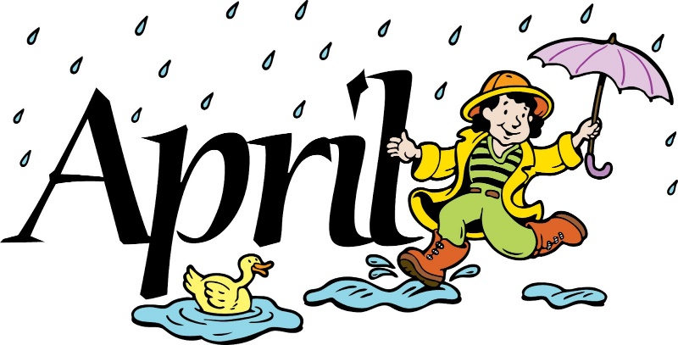  Please have your child practice 20min of reading/math each evening & send in headphones if he or she doesn’t have them    May 8th-last day of assigned lessons  May 22nd- last day to submit lessons    Olivier-May 1  Layla-May 13  Ivye-May 16
yellow | blue
pink | brown
green | black
purple | white
There were no April birthdays from our class. | Complete Spelling City Lessons  Use Brainpopjr. math, language arts, science and social studies

